|  |  |
| --- | --- |
| **2020 Year 11 ViSN Mathematics Specialist Units 1 & 2**  **Test 6 – Complex numbers & Proof**  **Section One – Calculator Free** | |
| Mr Daniel Comtesse  Mandurah Catholic College | Calculator Free:______/14  Calculator Assumed:_____/22 |
| daniel.comtesse@cewa.edu.au | Result: _____/36 ______% |
|  |  |

**Student Name:** ___________________________________________

**School:** ___________________________________________

**Time allowed: Section One - 15 minutes**

**Section Two – 30 minutes**

Assessment Date:

**Material required/recommended**

***To be provided by the supervisor***

This Question/Answer Paper

SCSA Formula Sheet

***To be provided by the candidate***

Standard items: pens, pencils, pencil sharpener, eraser, correction fluid/tape, ruler, highlighters

**Submission Details**

Timed Assessments are to be returned to the ViSN teacher by the ViSN mentor (scan completed assessment and email to teacher above) within 24 hours of assessment date (above).

**Instructions to Students**

1. **ALL** questions should be attempted.

2. Write your answers in the spaces provided in this Question/Answer Booklet.

3. **SHOW ALL YOUR WORKING CLEARLY**. Your working should be sufficient detail to allow your answers to be checked readily and for marks to be awarded for reasoning. Correct answers given without supporting reasoning may not be allocated full marks. Incorrect answers given without supporting reasoning cannot be allocated any marks.

4. If you repeat an answer to any question, ensure that you cancel the answers you do not wish to have marked.

5. It is recommended that you **do not use pencil**, except in diagrams.

**Question 1 [3, 2 = 5 marks]**

(a) Determine the values of the real constants $b$ and $c$ if $z=1+3i$ is a solution of the equation $z^{2}+bz+c=0$.

(b) Express the real quadratic polynomial $z^{2}-4z+8$ as a product of its linear factors.

**Question 2 [2 marks each]**

(a) A set of real numbers is given by $\left\{ \sqrt{2}, 3.\overline{14}, π, \sqrt[3]{14} \right\}$. Clearly show that one of the numbers in the set is rational.

(b) Prove that $9.\overline{9}≡10$.

**Question 3 [5 marks]**

Let $z_{1}$ and $z_{2}$ be complex numbers such that $2z_{1}+3z_{2}=7$ and $z_{1}+iz_{2}=4+4i$.

Determine $z_{1}$ and $z_{2}$ in the form $z=a+bi$, where $a, b ∈Z.$

**End of Section One**

Additional working space

Question number: _________

|  |  |
| --- | --- |
| **2020 Year 11 ViSN Mathematics Specialist Units 1 & 2**  **Test 6 – Complex numbers & Proof**  **Section Two – Calculator Assumed** | |
| Mr Daniel Comtesse  Mandurah Catholic College | Calculator Assumed:_____/22 |
| daniel.comtesse@cewa.edu.au |  |
|  |  |

**Student Name:** ___________________________________________

**School:** ___________________________________________

**Time allowed: Section One - 15 minutes**

**Section Two – 30 minutes**

Assessment Date:

**Material required/recommended**

***To be provided by the supervisor***

This Question/Answer Paper

SCSA Formula Sheet

***To be provided by the candidate***

Standard items: pens, pencils, pencil sharpener, eraser, correction fluid/tape, ruler, highlighters

Special items: 1 A4 (one sided) page of notes, up to three scientific and/or CAS calculators

**Submission Details**

Timed Assessments are to be returned to the ViSN teacher by the ViSN mentor (scan completed assessment and email to teacher above) within 24 hours of assessment date (above).

**Instructions to Students**

1. **ALL** questions should be attempted.

2. Write your answers in the spaces provided in this Question/Answer Booklet.

3. **SHOW ALL YOUR WORKING CLEARLY**. Your working should be sufficient detail to allow your answers to be checked readily and for marks to be awarded for reasoning. Correct answers given without supporting reasoning may not be allocated full marks. Incorrect answers given without supporting reasoning cannot be allocated any marks.

4. If you repeat an answer to any question, ensure that you cancel the answers you do not wish to have marked.

5. It is recommended that you **do not use pencil**, except in diagrams.

**Question 4 [3 marks]**

Show that if $n$ is one more than a multiple of three, then $n^{2}$ will also be one more than a multiple of three, where $n∈Z$.

**Question 5 [1 mark each]**

The complex numbers $u$ and $v$ are shown in the complex plane below.

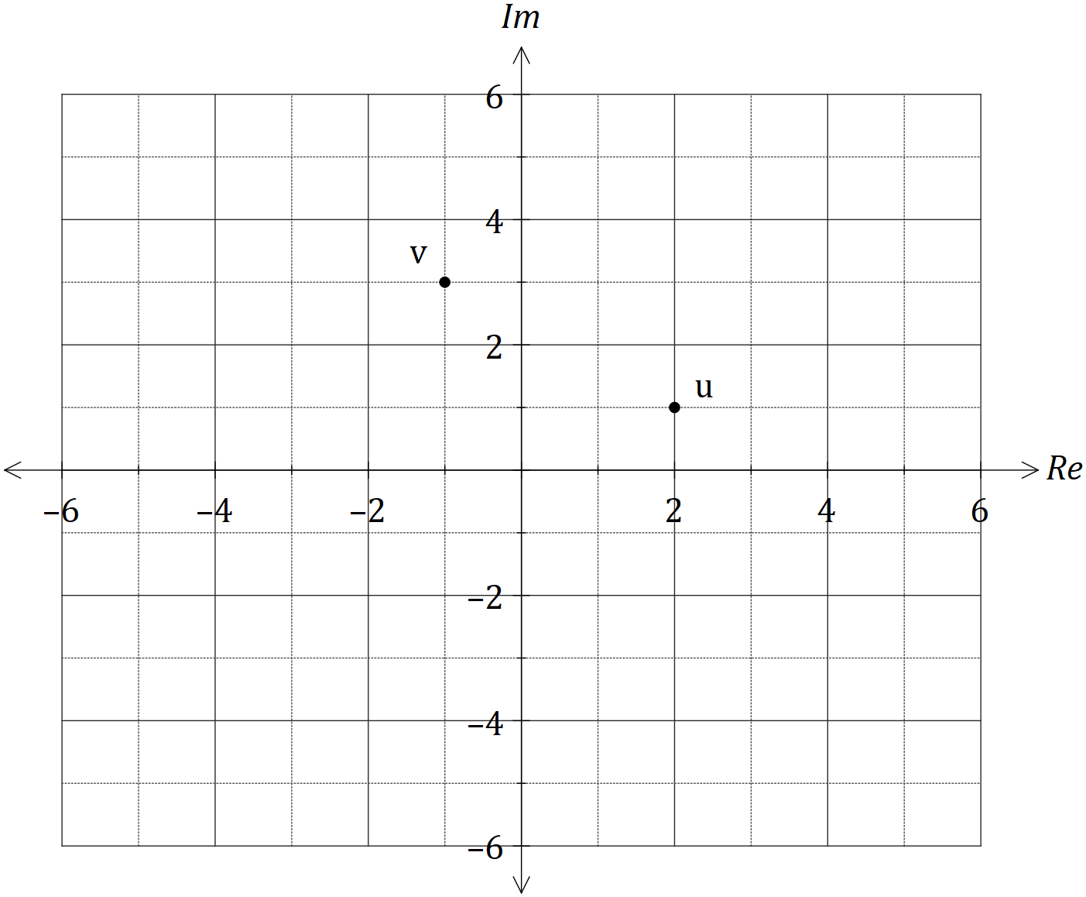

Plot and label the following complex numbers:

(a) $z_{1}=u+v$

(b) $z_{2}=2v-u$

(c) $z_{3}=\overline{v}$

(d) $z_{4}=\overline{u+v}-\overline{u}-\overline{v}$

**Question 6 [4 marks]**

Prove that $\sqrt{7}$ is irrational by contradiction.

**Question 7 [1, 5 = 6 marks]**

The sum of the first $n$ terms of the sequence $2+8+14+20+ .. +\left(6n-4\right)$ is $n(3n-1)$.

(a) Show that the statement is true when $n=5$.

(b) Use mathematical induction to prove the statement is true for $n∈Z ,n≥5$.

**Question 8 [5 marks]**

Use mathematical induction to prove that $7^{2n-1}+5$ is always divisible by $12$, for $n∈N$.

**End of Assessment**

Additional working space

Question number: _________